**Launch and Connect to an EC2 Linux Instance**

**Step 1:** Launching an EC2 instance

* Go to Amazon dashboard
* Select EC2

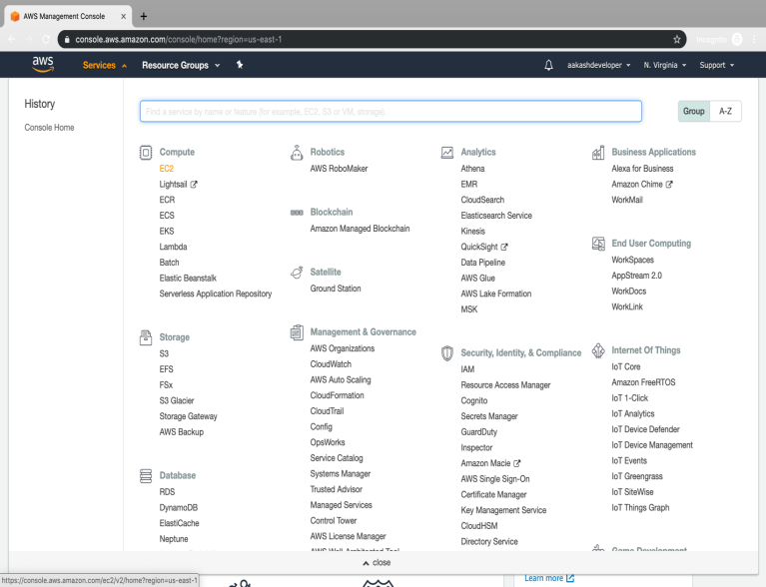

* Click on *launch instance* to run any instance

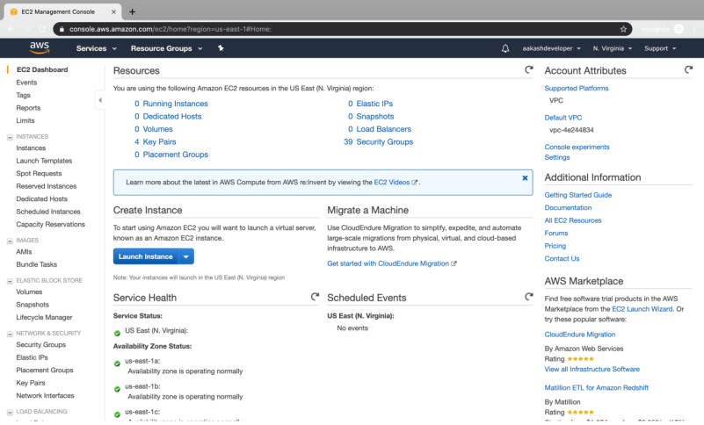

* Select the AMI

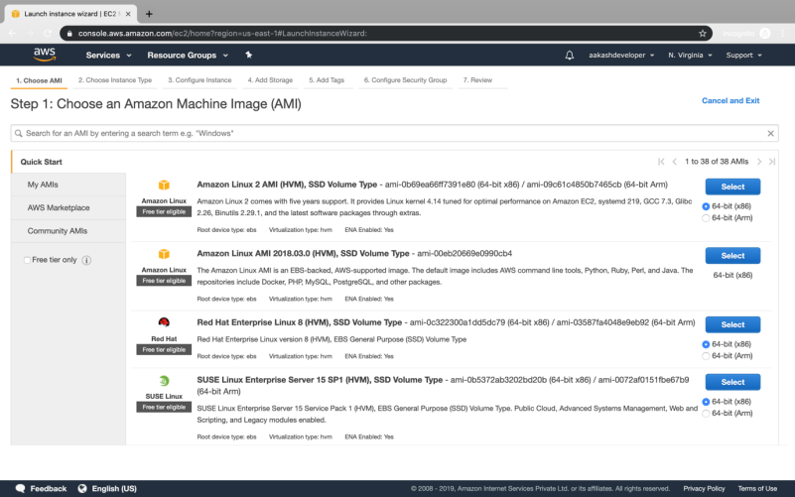

* Select t2.micro as the instance type

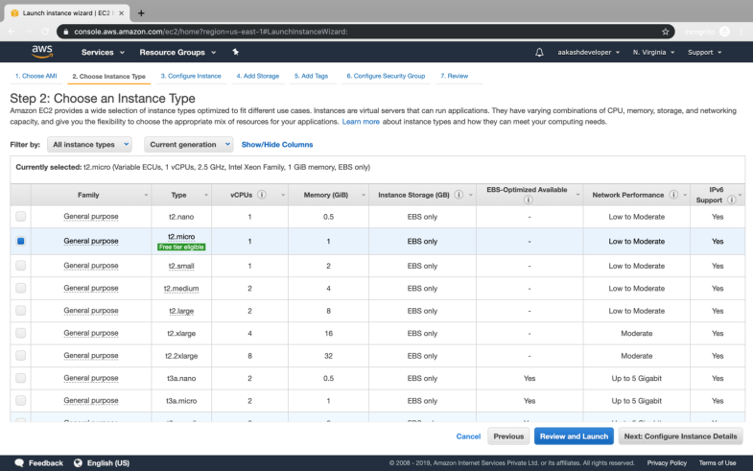

* Specify the number of instances, networks, placement groups, and IAM roles and click *Next*

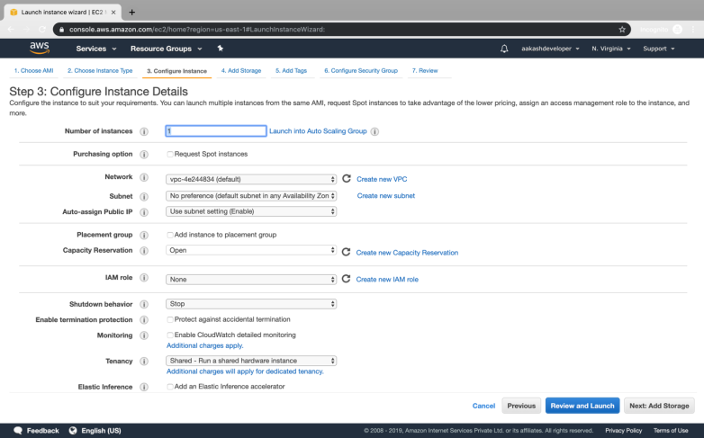

* There is one volume attached to the instance by default
* In Linux, the default volume attached is 8 GB
* You can add more volume if required

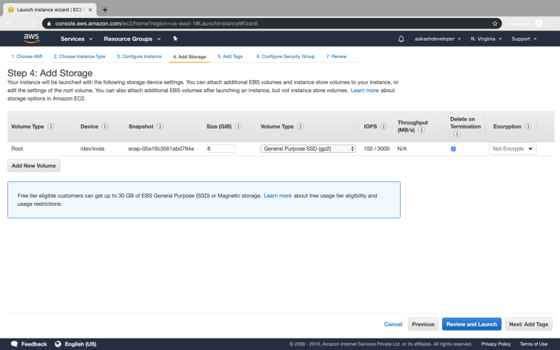

* You can add a key-value pair to the instance

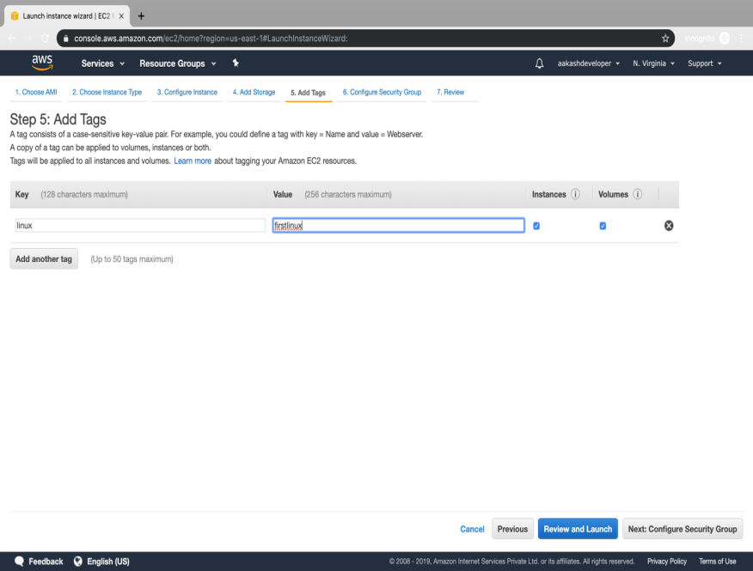

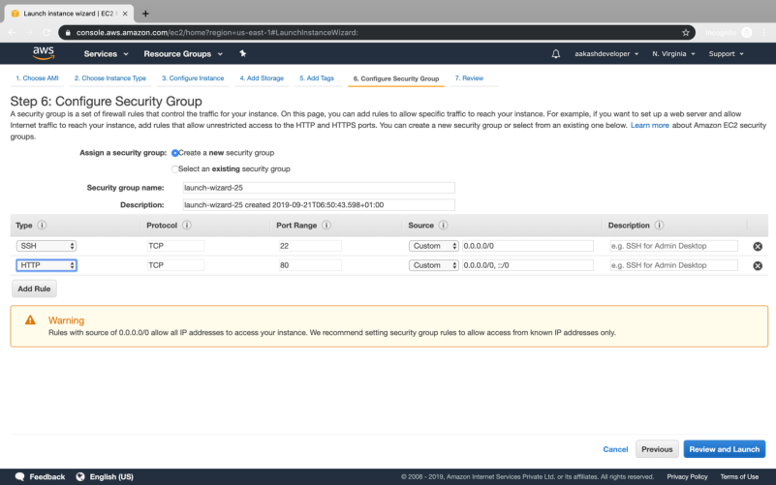

* Attach the three policy groups depending on the type of access required

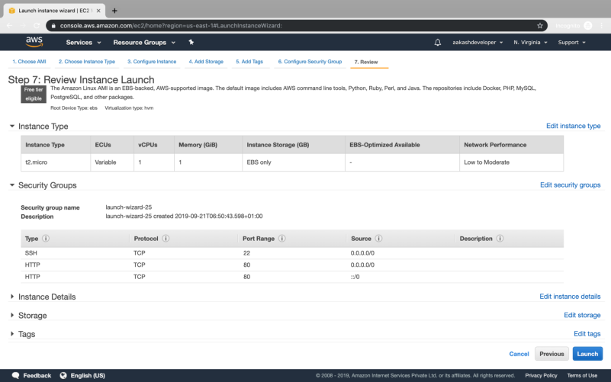

* Select an existing key-value pair to launch the instance

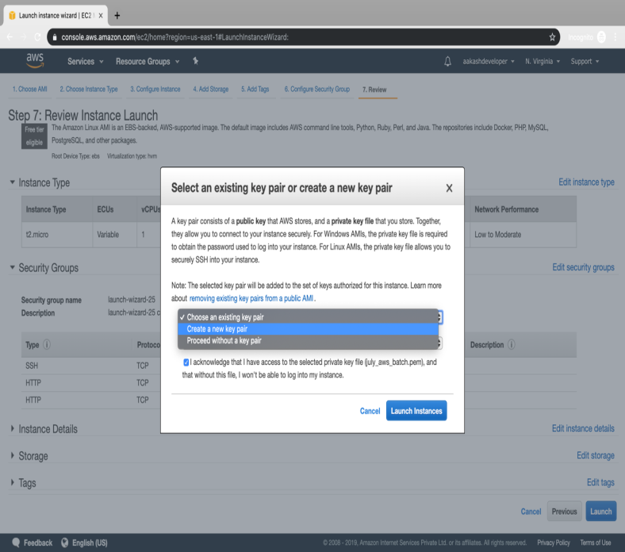

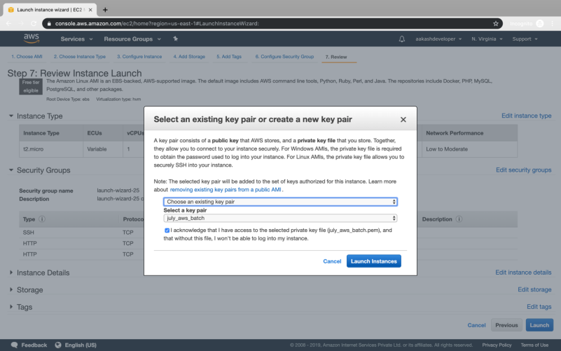

* The instance is ready to use

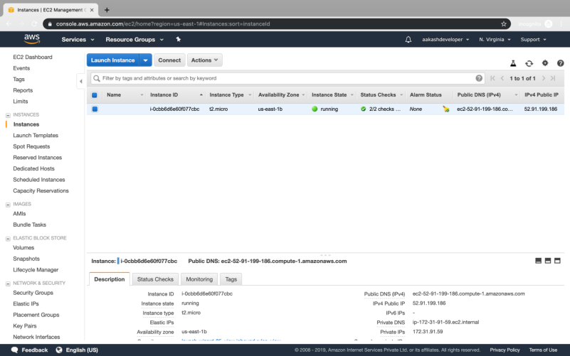

* Click on *Connect* on EC2 dashboard
* Run the ssh command provided

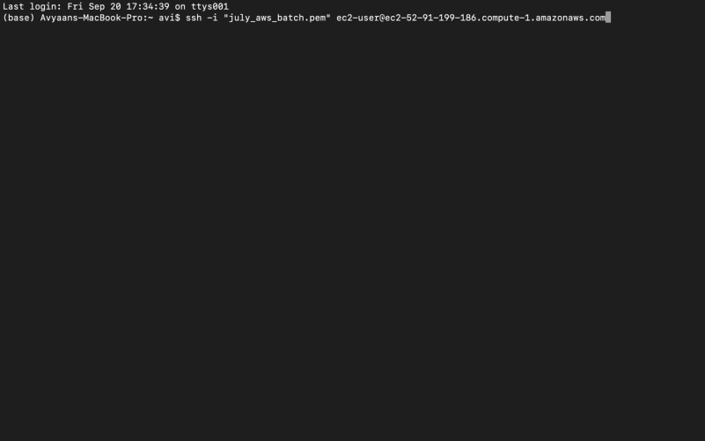

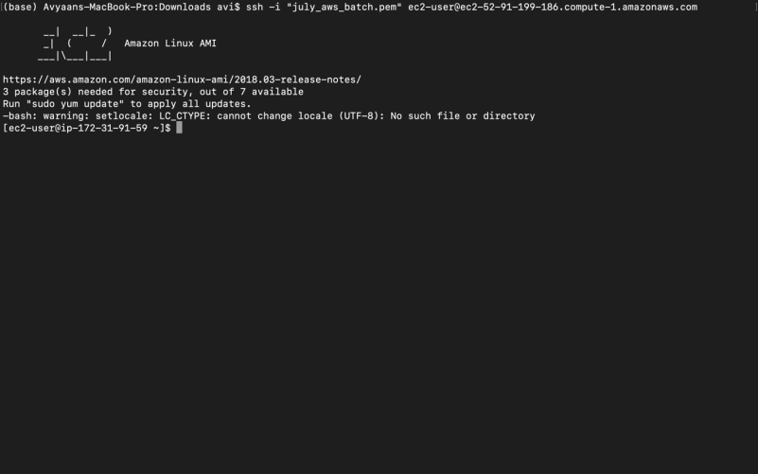

**Step 3.1.2:** Connecting to an EC2 instance

* Run the following command to launch a website over EC2:

*yum install httpd -y*

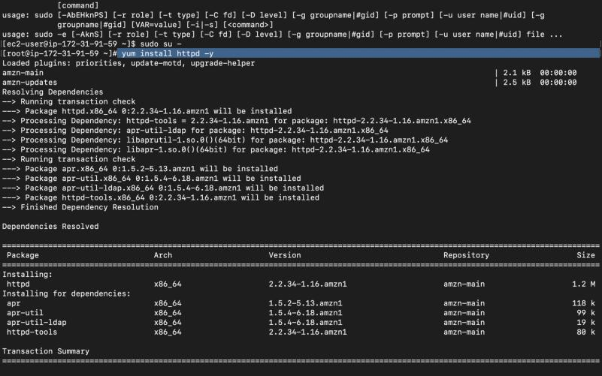

* Navigate to /var/www/html and create index.html file using command

*vi index.html*

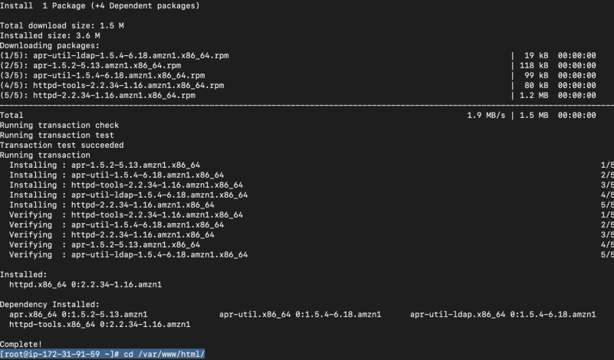

* Enter *I* and start creating HTML file content
* Once done, type *:wq!*

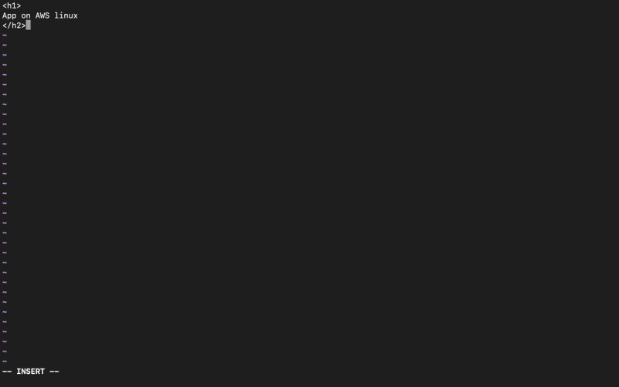

* Using public IP of EC2 instance, you can see your app running on the browser



